Meta Description:
Find your perfect-fit Custom Trousers for Men at Lucho. Expert tailoring, premium fabrics, and personalized style for comfort and confidence on any occasion.

How to Pick the Best Custom Trousers for Men in Houston? H1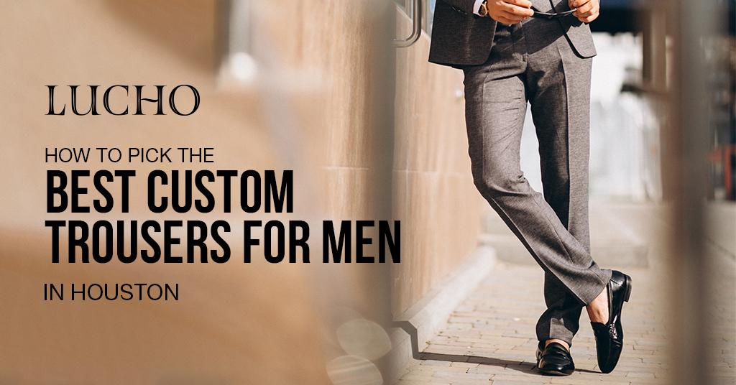
Every male wardrobe needs custom trousers because they significantly boost self-assurance and character expression. Due to the unpredictable weather of Houston and variable population demographics, finding suitable custom male trousers is particularly beneficial for wardrobe development.

Whether you are going through a business meeting, a wedding, a birthday party, a funeral, or any other occasion, choosing trousers to wear is a critical decision you have to make in the process of dressing.

At Lucho, we appreciate every man’s desire to look well-fitted, well-styled, and classy whenever he wears trousers and that is why we are here to help you to choose the best custom trousers for men in Houston.
Well, let us explain how you can make the next pair ideal for a given candidate.

Understanding Custom Trousers for Men H2
Men’s tailored trousers are more than pants. They are an embodiment of your fashion personality and a source of utmost comfort. Custom trousers, for instance, are much more suitable for a gentleman’s body shape because they are not made off-the-rack clothes but tailored to fit the wearer, both being comfortable and fashionable. This personalization can make a whole lot of difference to how you feel as well as how you appear each waking day.

Why Choose Custom Trousers? H2
Here are some advantages of wearing custom trousers over other simple trousers;

- Perfect Fit: This method enables you to exercise control in making the trousers fit the body shape and give the right figure.
- Flexibility: It allows you to make choices out of a wide range of fabrics, colors and styles to best suit your wardrobe. This is largely doable to the extent that the buyer gets an item from shelves that was not tailored in anybody else’s image but his or her own.
- Wear and tear: Customized trousers are made of superior qualities of fabrics. That’s why they tend to have greater durability than normal trousers and do not fade as easily.
- Versatility: Trousers are, in fact, versatile enough to be appropriate for formal occasions and also for casual occasions.

Key Considerations for Choosing Custom Trousers in Houston H2
The following General considerations are undoubtedly important in determining the specific best custom trousers for men in Houston. Here are the ways that provide you with the necessary help in making the right decision:

1. Identify Your Needs H3
To begin, you should identify your needs before making any decision regarding the purchase.. Are they casual clothes or formal clothes, or both, in other words are they wear them on every day basis or occasionally? These needs will determine the type of fabric to use, and the most appropriate fashion design and fit for the attire.

2. Choose the Right Fabric H3
Do evaluation on the basis of fabrication. You know very well that fabric is an important aspect of custom trousers. The weather conditions in Houston can still be hot sometimes, so you should wear clothes made from fine materials such as cotton, linen, or sheer wool. The blended wool fabric seems to have the best of both worlds in more official ambiance to provide a refined appearance with comfort.
- Cotton: Suitable for a variety of occasions and favorable for business and informal wear.
- Linen: Great for summer wear due to its lightweight and airy nature.
- Wool: This is best used when it comes to formal trousers because it is capable of giving structure and heat.
- Wool Blends: Incorporate the wool with other fibers to obtain better comfort characteristics.

3. Select the Perfect Fit H3
Perfect fitting matters a lot when it comes to trousers. You will get a better wearing experience if the trousers are specifically tailored to the individual buyer’s size and specifications. The appearance of a well-fitted pair shouldn’t be too close to the body or loose fitting, either. Consider the following fit aspects:

- Waist: Make sure it is snug on the body but it should not be too tight to cut into the skin around the waist.
- Thighs: It should be quite tight to accommodate your body size and also allow for ease of movement.
- Knees: To avoid such a pity, you should opt for a fit that would complement the shape of your knees.
- Seat and Crotch: We recommended the usage of a slim fit without the seat being overly tight or too loose. As for the crotch length it should not be too long so as to hinder mobility.

4. Decide on the Style H3
The style of the trousers should be determined by your preference and the function you intend to attend in the outfit. Common styles include:

- Classic trousers: A cut that will never go out of style, straight or with a slight slimming toward the bottom.
- Chinos: They are acceptable for business casual wear and other relatively relaxed setting.
- Cargo Trousers: Best for outdoor wear with additional pockets and design for more tough wear and use.
- Business Pants: Formal wear material, slim fit, and comes with creases.

5. Consider the Color and Pattern H3
You should choose the color and pattern of the trousers because color and pattern play a very important role in how trousers look.
Some of the preferable colors are those which are neutral including navy, grey, and black color as they are flexible enough and can easily be worn with other products.
In case you want something more daring, opt for the detailed patterns such as checks or subtle stripes in order to invigorate the general image of your trousers.

6. Choose the Right Tailor H3
It is important that you get the right tailor to cater to the need of sewing your custom trousers to perfection. There are many tailors in Houston who specialize in designing and stitching men’s trousers to individually made measurements. Go searching for opinions, ask friends or relatives about the good salons, and, if you can, go to their workshop to discuss your requirements.

7. Budget Wisely H3
There is a vast difference in the price range of the custom trousers due to factors such as the type of fabric used, nature of style and skill of the tailor. It is very important to set a budget which corresponds to the quality and the detail level that is required. Just to remind you, a good pair of trousers should be purchased, as, apart from saving your money, as you will not have to buy them for a long time.

The Lucho Advantage H3
At Lucho, we know that we offer the most excellent custom trousers for men in Houston. Every custom trouser is designed by our expert craftsmen with a lot of detail to meet our client’s requirements. Here’s why Lucho stands out:

- Expert Tailors: We have well-experienced men’s trouser tailors, who have a lot of professionalism in the making of these trousers.
- Personalization Services: Our tailors listen to you and come up with the best style and size that suits you best to your requirements.
- Fabric quality: Only high-quality fabrics are used to ensure that the trousers are of the highest quality and comfortable at the same time.

Ending Note H3
The process of choosing the best custom trousers for men in Houston is one that improves the quality of your wardrobe and self-esteem. When you understand your needs, choose the fabric appropriately, have the garment fitted well, and find an expert seamstress, then custom trousers will give you the best comfort and elegance you have always desired.

We at Lucho are fully dedicated to assisting you to get the perfect fit custom trousers for any occasion. Stop by and check out the extensive range of our custom-made trousers.
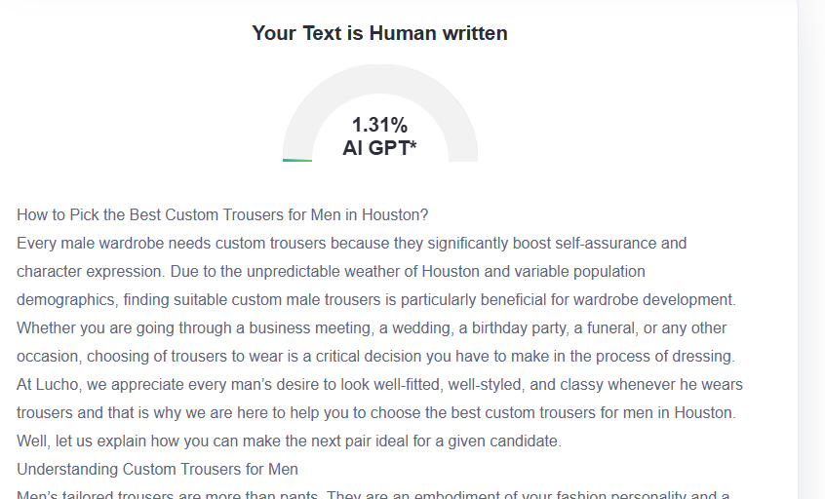

GMB
Looking for the perfect custom trousers in Houston? At Lucho, we understand that well-crafted trousers are essential for every man's wardrobe, boosting confidence and expressing personal style. Custom-made trousers outperform ready-to-wear trousers by providing shaped fits made for individual body types and luxury material selection, as well as multifunctional use for formal and casual clothing needs. The climate in Houston requires you to analyze your individual requirements before choosing custom trousers. Expert tailors at our shop suggest using quality materials for business casual events, followed by linen for Houston's heat. At the same time, fine wool and wool blends function best for structured formal attire. Ideal-fit trousers create remarkable outcomes because they fit perfectly at your waist while offering enough freedom for your thighs and the natural execution for your knees combined with appropriate measurements in the seat and crotch. Whether you prefer classic cuts, business pants with sharp creases, casual chinos, or practical cargo styles, our skilled craftsmen at Lucho can create exactly what you need. Visit Lucho today and let our professional tailors help you select the best custom trousers in Houston - an investment in your wardrobe that provides lasting confidence, comfort, and style.

